- Introduction

  - Rapid Growth of Gaming

AR games has gone beyond face filters and widely adopted by the organization. They provide the user with the ultimate gaming experience. It includes advanced features which make games extremely addictive.The rapid growth of augmented reality game development helps in developing engaging games and grow the overall gaming market.

Mobile gaming takes the largest chunk of the gaming market thanks to access to affordable smartphones growing at 15% year-on-year for the past five years in India, high-speed 4G internet penetration and the world’s lowest data tariffs. Together with the rise of mobile games, these factors feed into India’s youth having a growing appetite for content.

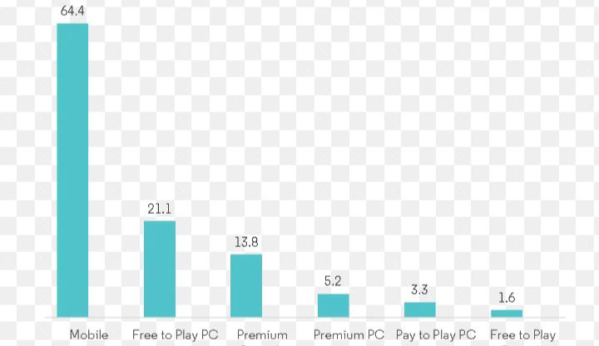

Figure 1: global gaming market 2010-2020.

  - Benefits of AR Games

AR games increases innovation and responsiveness for games. They give new experience to the player. They are a source of attraction for players around the world. Further they make user experience a lot more different than other genres of Games.
1.2.1 Make Appealing Games
Make Appealing Games Augmented reality in gaming industry creates a three dimensional experience for the users and allow them to feel that they are interacting personally with their digital environment.This technology helps to drive the attention of millions of obsessive gamers and deliver an unforgettable experience.

    - Better Consoles
Choosing the greatest console is a lot harder than your imagination due to the exceptional gaming market.For obsessive gamers and developers, AR technology is best to meet their imagination

    - Replacing Traditional Games

Augmented reality is really putting pressure on other categories of gaming.AR is giving intense competition to other types of games many other categories are coming up with creative ideas so that they can cope up with the ever changing trend of gaming .It’s bringing revolution in the gaming industry and introducing new innovations and creativity in the market. These apps are written in special 3D programs.This allows users to play level up animation and provides with transforming transactions

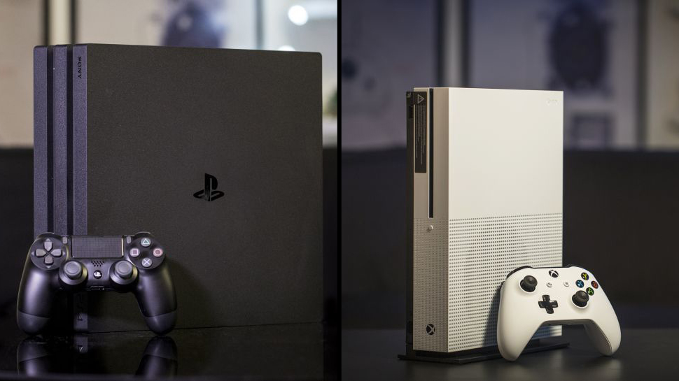
Fig 2 : better consoles.
1.2.4 Technologies for AR Games.

TECHNOLOGIES FOR AR GAMES
Mid-generation advancement and technology rise has taken AR game development on another level. For gamers and developers, there are multiple options available, using that they can make your vision and imagination unbeatable.There are incredible game development companies who have started using augmented reality keeping the latest trends in mind all over the world.

Unity 5
ARPA
XCode 7
Wikitude
Vuforia
AR games are designed for multiple platforms. It has blurred the line between what is real and what is computer generated . Not just that It’s changing the forever way of people use and interact with technology.

- AR And The Future of Gaming
It’s a groundbreaking technology which really brings something innovative and creative in the market every single time. It is one of the successful technology, which brings digital creation to life. For developers around the world, it’s creating immense opportunities. It has a great contribution towards increasing computing capabilities of our smartphone. It’s an incredible technology, capable of providing a great experience converting a field into a battlefield.

This prominent technology allows gamers to interact with the real world in digital form while experiencing a real-life environment.Technology is changing the world at a rapid phase as a whole giving

2.1 Cloud providers Become the new game console
Widespread cloud adoption and access have changed the way video and mobile games are created, delivered and played. The time-to-market acceleration is dramatic. Players are now able to access new games regardless of location if they have an internet connection, reducing the amount of time needed to acquire games, expansion packs and add-ons.

Unlike game consoles, cloud gaming moves content execution from the console to the cloud. Players stream games as compressed video frames just like you stream videos on Netflix. The difference is the videos respond to user input; when a key is pressed, the input is sent to a remote cloud server — which then sends a new video frame. This all happens in a fraction of a second and looks just the same as a game that was downloaded onto a device.

3.The rise of augmented reality gaming
Augmented Reality (AR) Technologies have long been exciting and interesting, but their practical application – has been limited at best. However, things are starting to change with, with their development and adoption coming a long way in recent years. Although these advancements represent 1% of the change we will see by 2020, we’re truly beginning to see the sheer potential as they enter new industries. Education & therefore Physical Education will be NO different.

Reality and how it’s begun to impact theoretical Physical Education and the teaching of things such as Anatomy. However, we’re now starting to see how this could impact practical situations with Augmented Reality Gaming being a likely contributor.

With this in mind let’s take a look at two incredible augmented reality games that blend technology and physical activity into a truly amazing immersive experience.

Pokémon Go‘
You may not remember the blockbuster cartoon from the 1990’s, however, last week saw the release of the eagerly awaited ‘Pokémon Go‘, an augmented-reality game developed for iOS and Android devices. This incredible game allows players to capture, battle, train, and trade virtual Pokémon who appear throughout the real world. Therefore players actually have to move and search far and wide in the real world to discover Pokémon, level up and defeat gym bosses. This has resulted in thousands of people participating and meeting in a global phenomenon the likes of which we have never seen before. Check out the video to see how it all works.

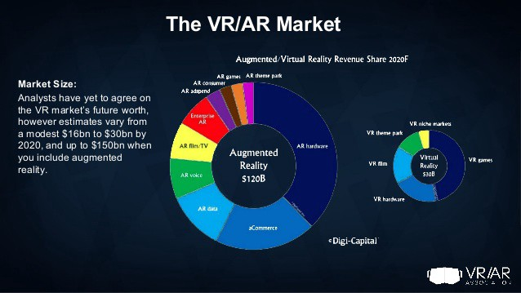
Fig 3: marketing strategy of AR gaming.

3.1 2020, consumer augmented reality (AR) spending is expected to reach $7 billion and the total downloads of AR apps are predicted to exceed 5.5 billion by 2022. Augmented reality technology presents numerous opportunities to optimize mobile marketing and significantly improve critical measurements such as retention and engagement. Moreover, using AR for mobile marketing enables you to innovate and optimize your user experience. In this article, we break down what augmented reality is, how it works and the benefits of using this technology.

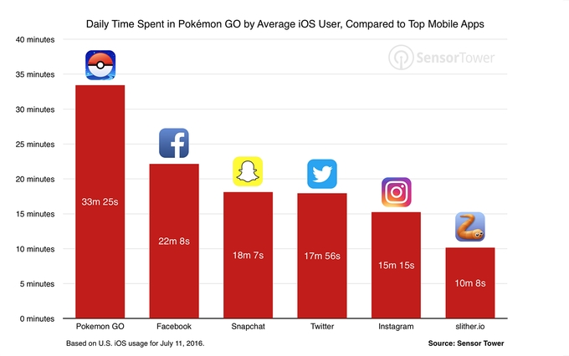
Figure 4: marketing strategy of Pokemon go game.

3.2 GO leverages an existing platform (smartphones) and layers in the game as augmented reality (AR), versus opting for a sexier platform like virtual reality (VR) that would require a new device. The game uses an application that even people who don’t play games on their smartphones are familiar with: global positioning system (GPS), which eliminates another adoption barrier for new users

4 Some important questions.
What games use Augmented Reality?
Augmented reality is still a new concept but there are a lot of games that use Augmented Reality Brickscape, Egg, Ghostbusters World, Harry potter, Wizard Unite are some games that are best when it comes to Augmented reality

What is the difference between AR and VR games?
AR adds digital elements to the real environment often by using the camera on smart phone examples include snapchat and Pokemon game. On the other side VR shuts down the physical environment. The best VR games include No Mans Sky, Superhot and Defector.

How is Augmented Reality used in gaming?
It’s a technology that works on computer “vision based recognition algorithms” which helps in adding intense sound, video and graphics the extra digital layer makes AR a distinctive technology in gaming.

Is AR the next big thing?
A survey suggest that AR is the way to go for gaming. Respondents were of the view that AR gaming will become a regular part of our smart phones. Many said that this technology will bring revolution in the world of gaming by creating different patterns of game.

Thank you for visiting my project file.

